Data Analysis

All the source code and the original graphs of this annex can be found in the folder “Data Analysis” of the Malaria Colombia online Git-Hub repository (Bernal-García, 2017).

# **Mean Monthly Air Temperature at Nuquí**

## Seasonality

Mean monthly air temperature at Nuquí doesn’t have a constant seasonality. Altough there are some years (1994, 1995, 1998, 2003 and 2004) that have higher temperatures at the beginning of the year and lower at the end. Other years (1996, 1999, 2000, 2001, 2002 and 2005) have lower temperatures at the beginning and at the end of the year, and higher temperatures between March and June.

## Annual Cycle

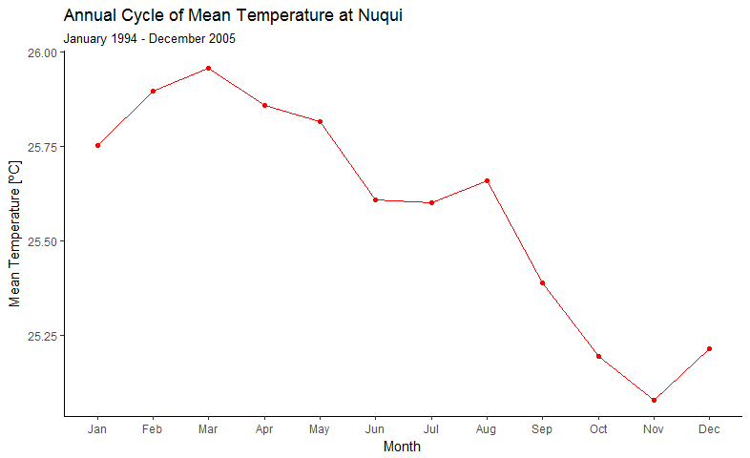

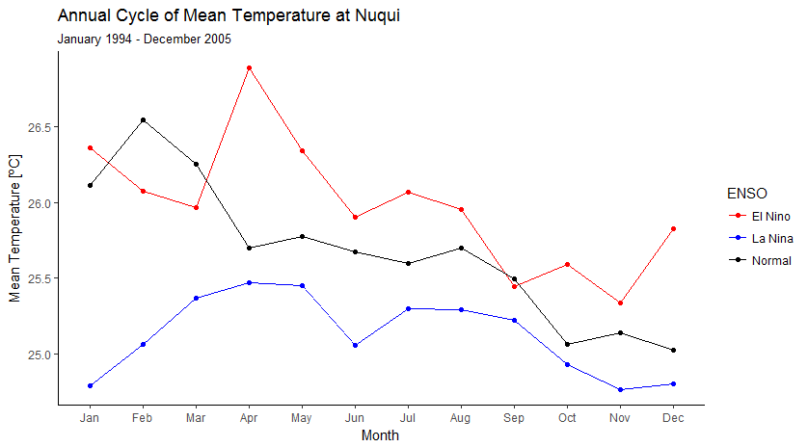

The annual cycle of the mean monthly air temperature at Nuquí exhibit a unimodal pattern for all the study period. The “hottest” month of the year is March with a mean temperature of 25.95 ºC, and the “coldest” month is November with 25.05 ºC. This means that in average inside the year the mean temperature only changes 0,90 ºC, a small variation between months. However one can find that in average the daily temperature range is 6 or 7 ºC depending on the month of the year and the ENSO conditions in the pacific (See section #). Its remarkable the fact, that only the annual cycle of El Niño temperature coincide with the same graph of cases, with a peak in April. Neither La Niña nor Normal cases match the observed mean temperature annual cycle. In general El Niño years are hotter than Normal, and Normal hotter than La Niña. Only February, March and September El Niño mean temperatures are below or almost the same than registred in Normal conditions.

## **Boxplots**

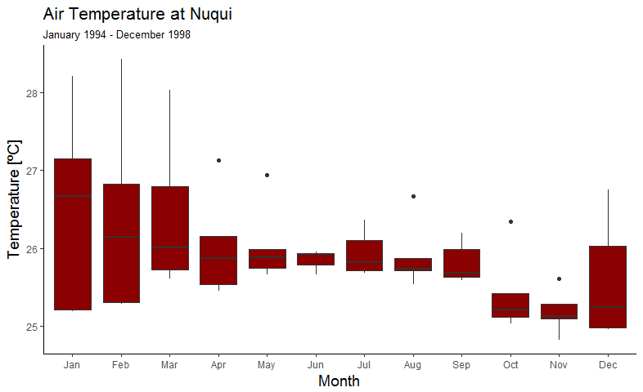

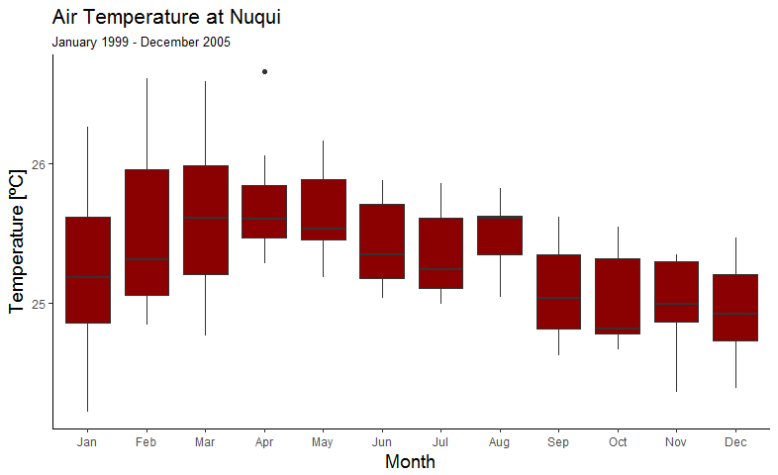

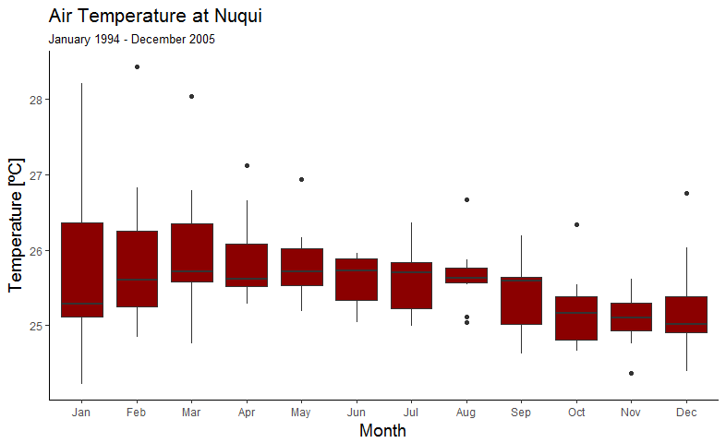

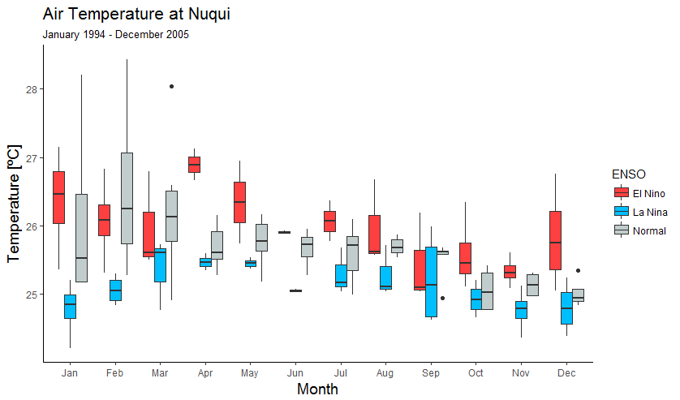

From 1994 to 1998 the mean monthly air temperature behave very similar to the mean monthly air temperature for Normal conditions with higher temperatures records in January and lower in October and November. January, February, and March remain the most variable alongside December. In the other hand, between 1999 and 2005 the seasonality of air temperature looks very similar to the first graph of section 1.1 with one peak in April. It also keeps the high variation of the first three months of the year.

# **Total Monthly Precipitation at Nuquí**

## Seasonality

The total monthly precipitation at Nuquí is the only variable that have the clearest seasonality. Although some years follows a unimodal pattern with lower levels of rainfall recorded on January and February followed by an increase up to a maximum around September and November (1998, 1999, and 2005), or around July (1996, 2002, 2003). In the other hand, there are years (1994, 1995, 1997, 2000 2001, and 2004) that exhibit a bimodal pattern with a small first peak around May and a big second peak around September.

## Annual Cycle

Once averaged the total monthly levels of precipitation at Nuquí for all the study period, one can identify a unimodal pattern with a peak in October and a trough in February. From July to November the rainfall levels are around 800mm per month, and from January to April below 400 mm.

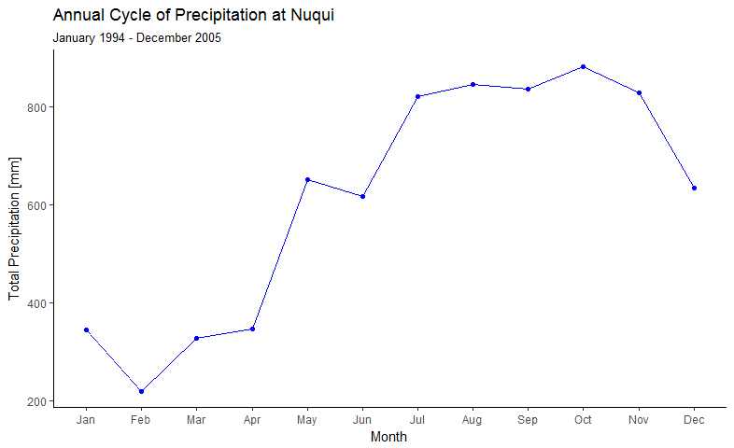

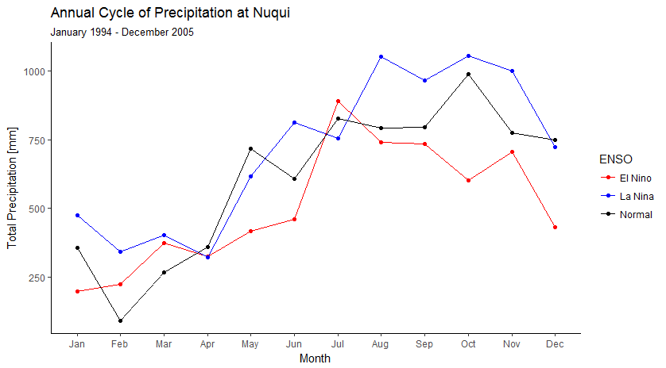

## **Boxplots**

The highest median of precipitation for all the study period is August, and the lowest February. July, August, October and December are very variable, while April and May the less dispersed.

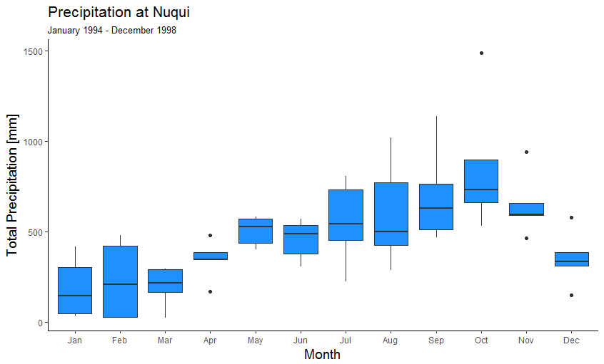

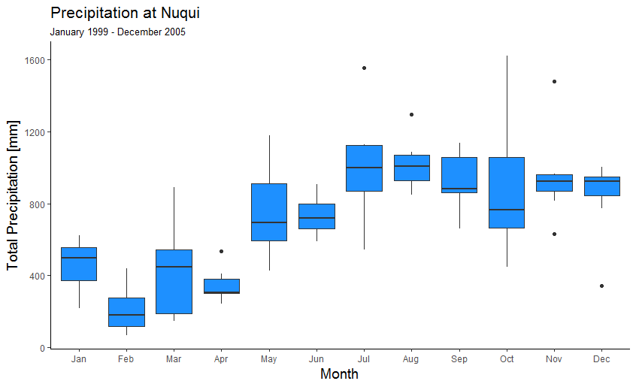

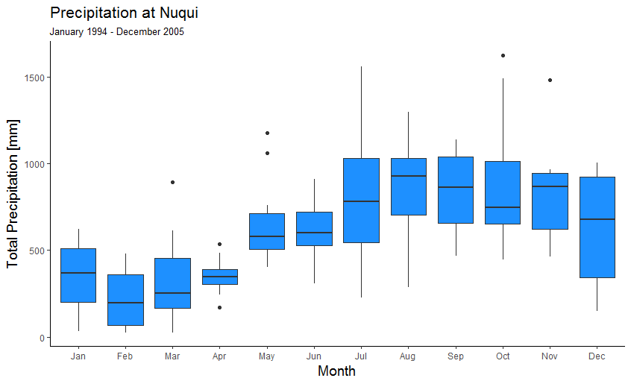

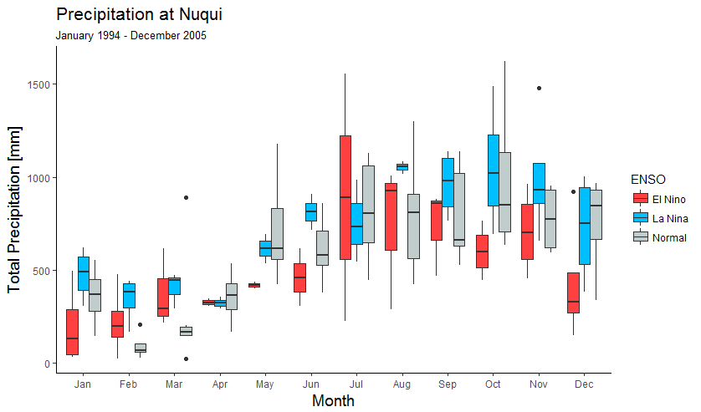

# **Total monthly *P. falciparum* cases at Nuquí**

## **Seasonality**

There seem to be no seasonality in the cases. I have also analyzed each year individually, and there are all different.

## Annual Cycle

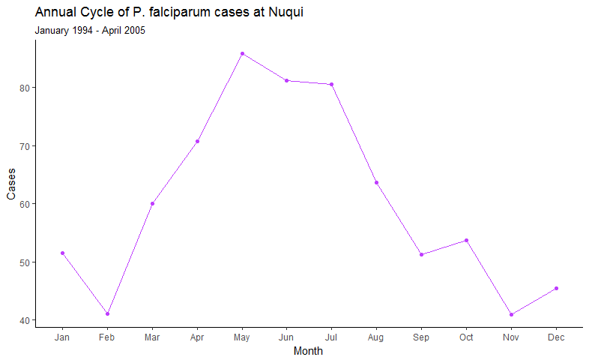

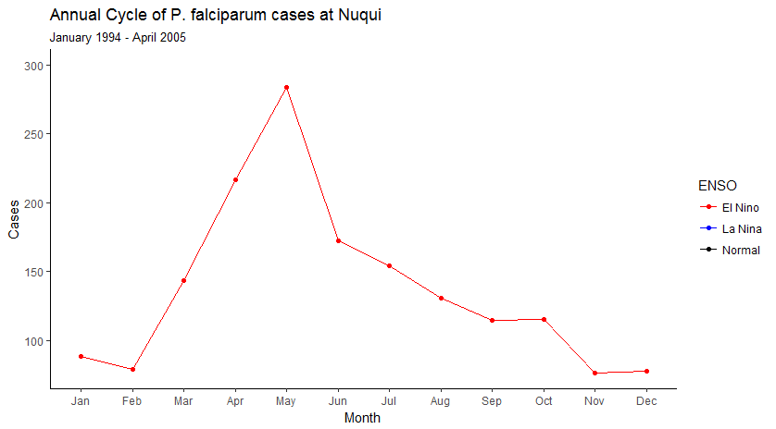

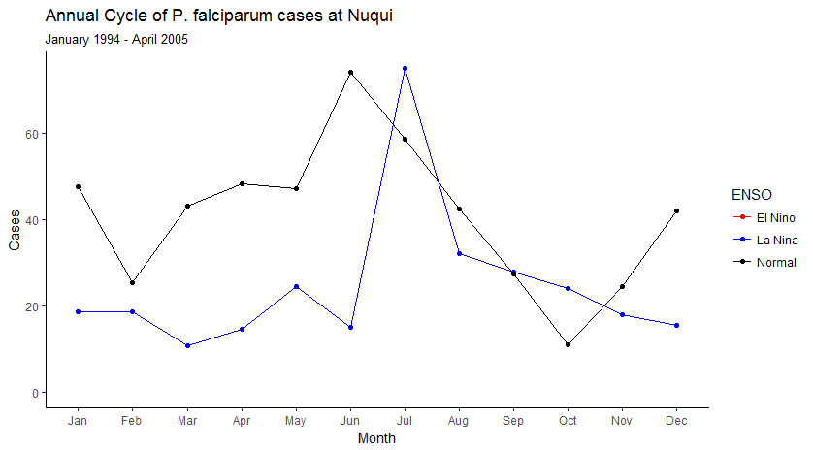

The average number of cases for each month (purple) shows a one-peak behavior, with high number of cases between May and July, and low report of them between November and February. If ENSO conditions are considered the seasonal behavior change. For El Niño months (red) the high number of cases appear on May with lower cases between November and February. Normal months (black) exhibit two peaks, a high peak in June, and a lower peak in January, with two troughs in October and February. In the other hand La Niña months (blue) have higher cases in July followed by a decrease until December. Starting from January cases decrease until March, when they start to increase to the high peak in July, with a little decrease in June. Overall cases reported on El Niño are higher than those reported on La Niña and Normal. And cases reported on Normal conditions are above those reported on La Niña except for July and October.

## **Boxplots**

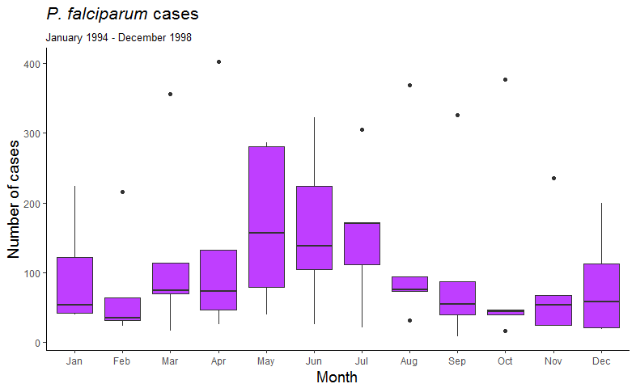

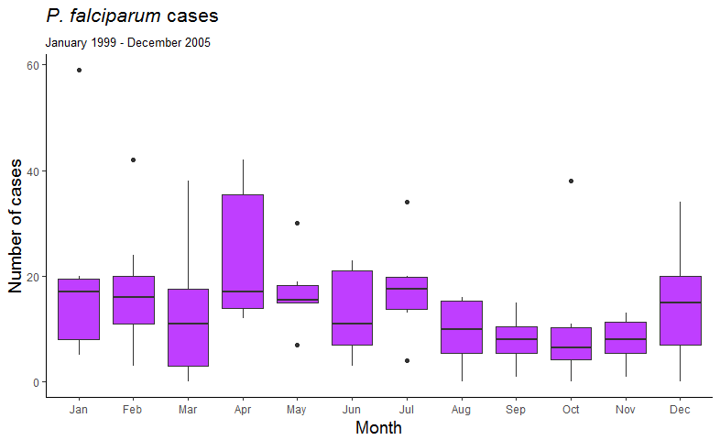

**From 1994 to 1998 a clearer seasonality is identified, very similar to the annual cycle. May, June and July has the highest median report of cases and a high dispersion. The months from October to February has the lowest median report, with great dispersion on December and January, and a lower one on October and November. In the other hand the seasonality of the years from 1999 to 2005 it’s not recognized on a first look.**

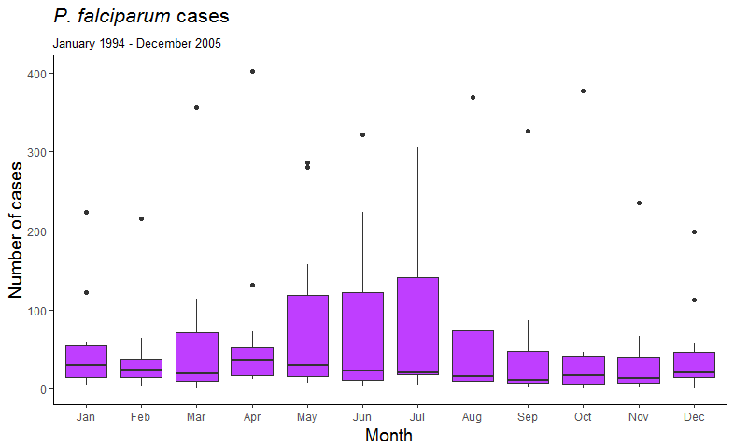

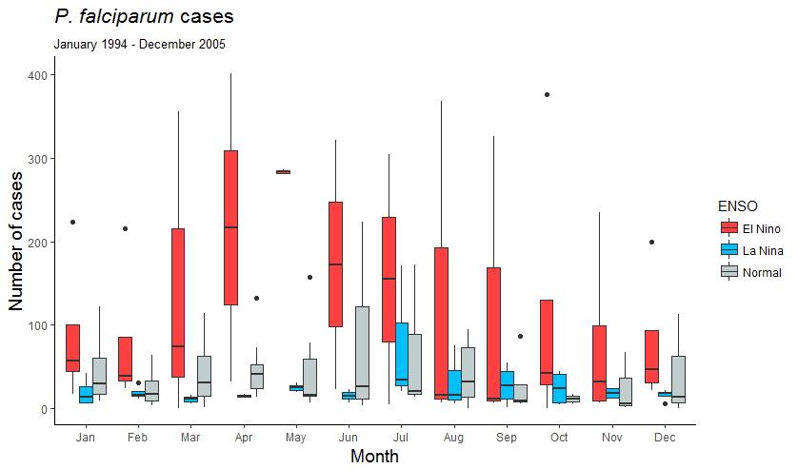

**The boxplot that consider all the study period doesn’t show any clear seasonality. It rather shows a great variability in the cases of May, June and July, being the most variable month June. From the same boxplot with ENSO conditions, you can observe that for all the months except for August and September, the median of El Niño cases is above Normal and La Niña. Although through all the year, El Niño cases are more variable; June and July are the most variable months for Normal and La Niña.**

# **Total number of *An. albimanus* female mosquitoes at Nuquí**

## Seasonality

For mosquitoes there is not a clear seasonality. 1998, 2002, and 2003 have a similar seasonality: a first peak in May or June, followed by a decrease until August or September, where they rise up again to a second peak in September or October, after this second peak they decrease again in October or November, and increase to a third peak in November or December. In respect to the other years, the 2000 and the 2005 have a lot of missing data; and 1999 have a trough in April, one peak in May-June and a little descend in July, after which they star to increase again until November (January, February and December are NA). The 2001 have very few mosquitoes the first 7 months of the year -with a little increase in May-, after which they start to increase to a peak in October. Finally the 2004 have few mosquitoes all the year and one peak in June.

## Annual Cycle

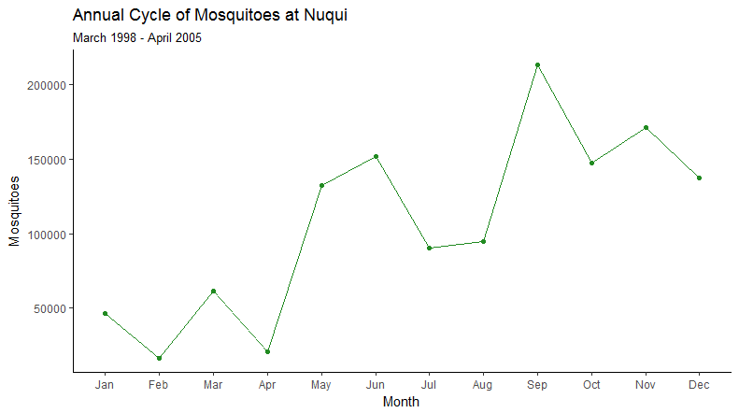

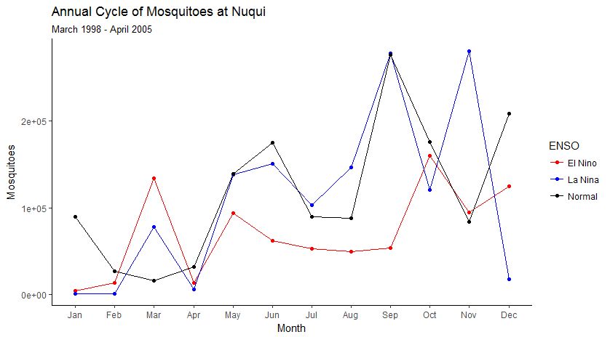

Once averaged, the number of mosquitoes exhibit an oscillatory increase since January until a maximum in September. Mosquitoes have peaks in March, May, June, September and November, and lows in the other months. It’s remarkable the fact that the seasonality of mosquitoes changes with the ENSO. This means that the timing of peaks and troughs change but not the oscillatory increase trend.

## Boxplots

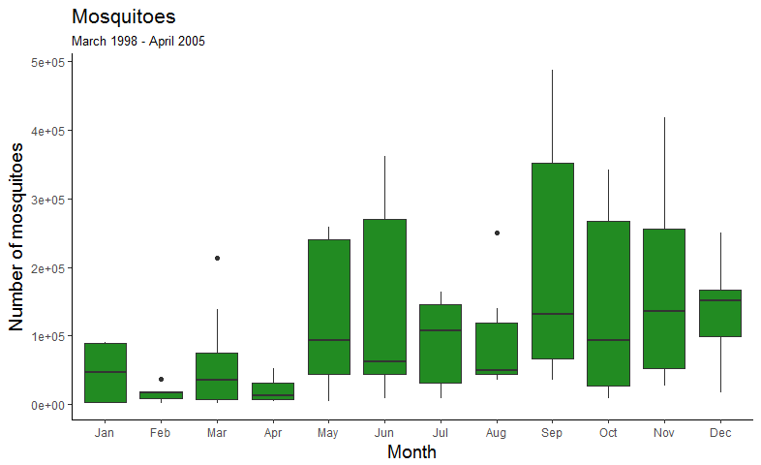

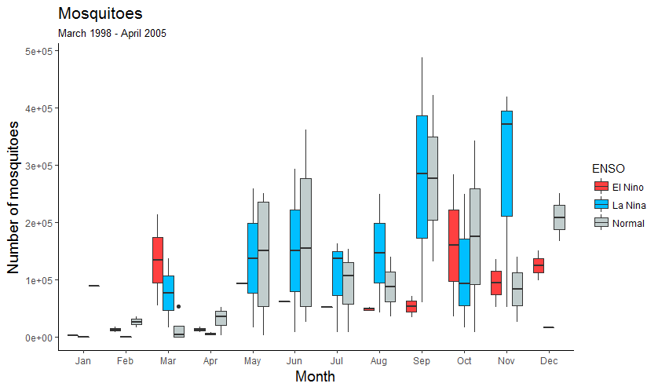

The boxplots of mosquitoes confirm the oscillatory increasing trend identified in the annual cycle. With very few variability in the first four months of the year, a medium dispersion in July and August, and a high one the rest of months. The most variable months are June and September, and the less are January, February and April.

# Cases and air temperature at Nuquí

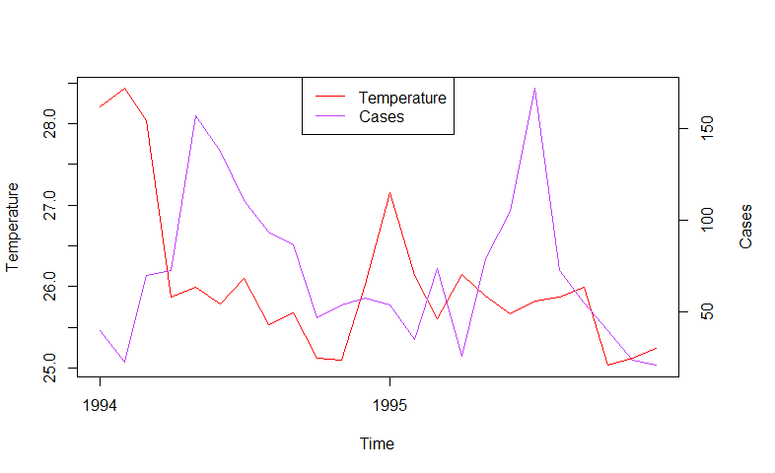

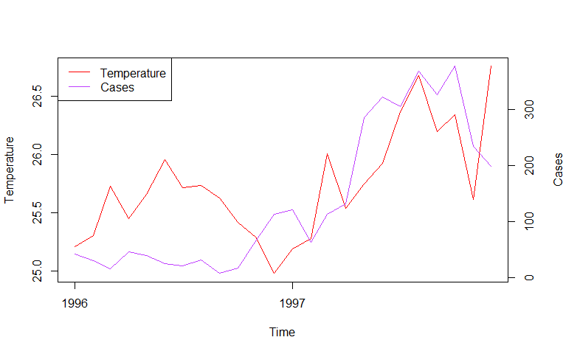

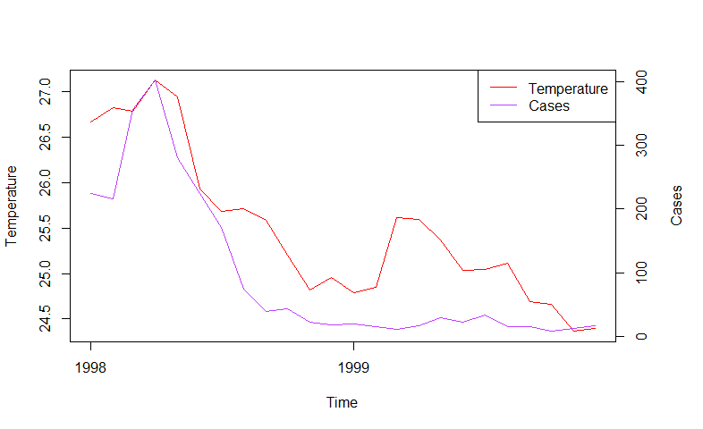

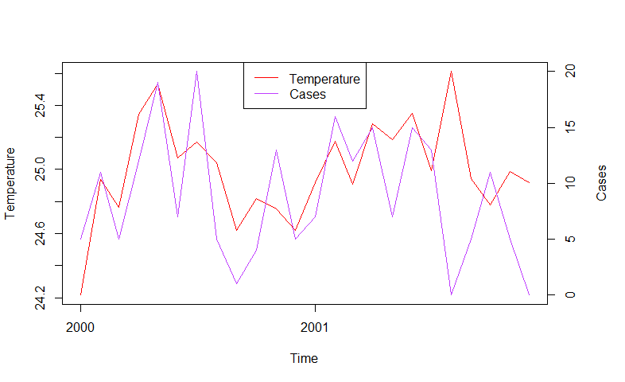

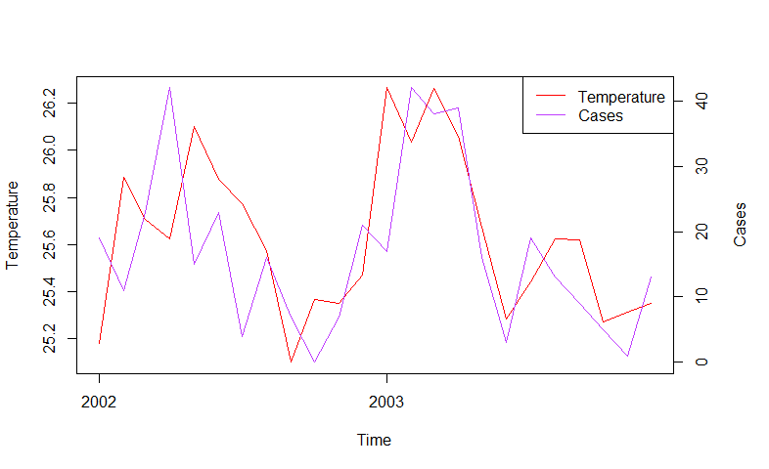

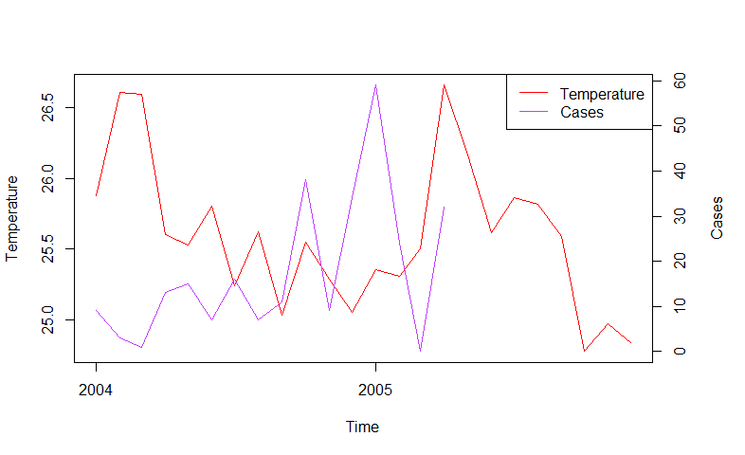

Cases from 1994 to 1995 seems to track temperature with a delay of a few months, while 1996 cases do not reflect any effect of temperature. In the other hand reported cases on 1997 and 1998 follow very close the temperature variations, and 1999 cases do not reflect any changes in air temperature. The cases dynamics from 2000 to 2003 are very tight to temperature dynamics, with only two months on 2001 with zero reported cases, which could be due to an administrative unreport. Finally, 2004 and 2005 cases try to follow temperature dynamics with a delay.

# Mosquitoes and Precipitation at Nuquí

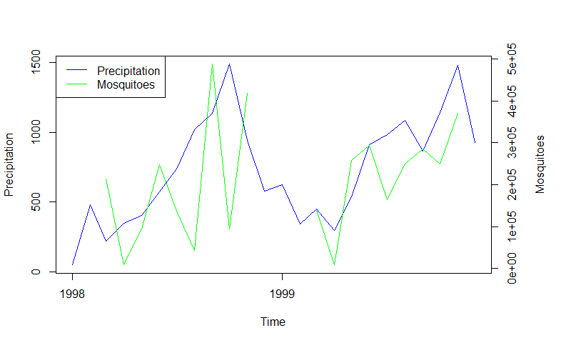

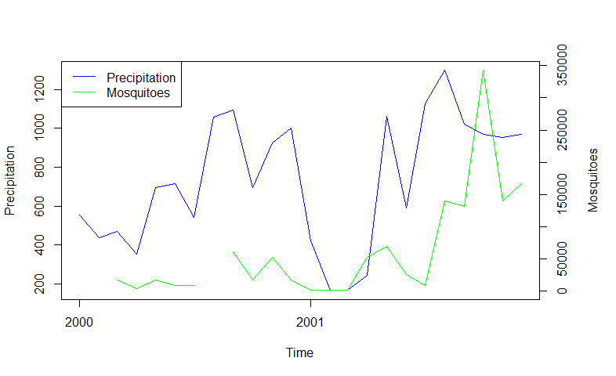

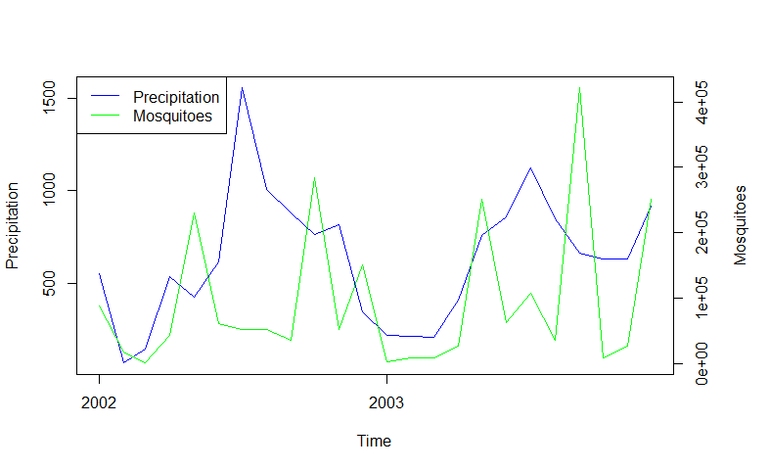

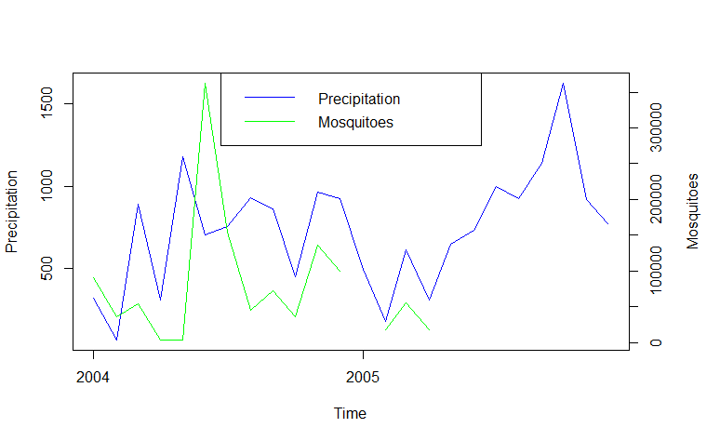

1998 mosquitoes track precipitation with very drastically oscillations around it, while in 1999 mosquitoes follow more smoothly changes on rainfall. In the 2000 mosquitoes are very few but try to follow rainfall dynamics and in the 2001 they increase their number and continue to follow changes on precipitation. Mosquitoes captured on 2002, 2003, and 2004 also follow rainfall changes with some interesting troughs in two peaks of rainfall around the middle of 2002 and 2003. In general one can say that the mosquito population follow rainfall dynamics with an oscillatory behavior, and I would not reject the hypothesis of an induced larval mortality in some high levels of rainfall.

# Diurnal Temperature Range (DTR)

I have added this variable to the analysis given the small range variability of the mean monthly temperature and that the DTR is the most dominant characteristic of climate variability in the tropics (Poveda, 2004).

## Seasonality

The DTR doesn’t exhibit nor seasonal pattern either.

## Annual Cycle

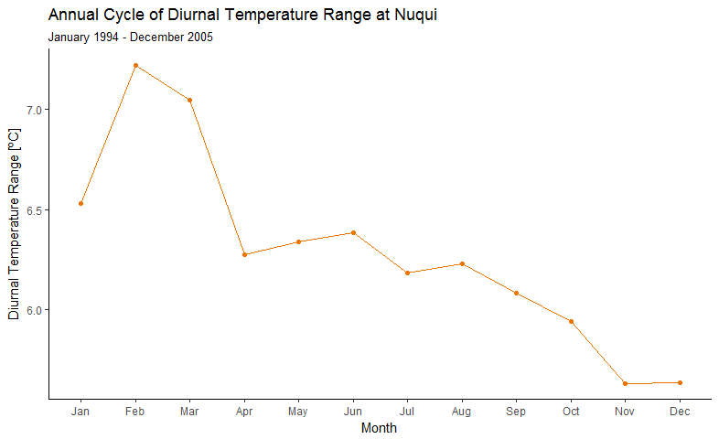

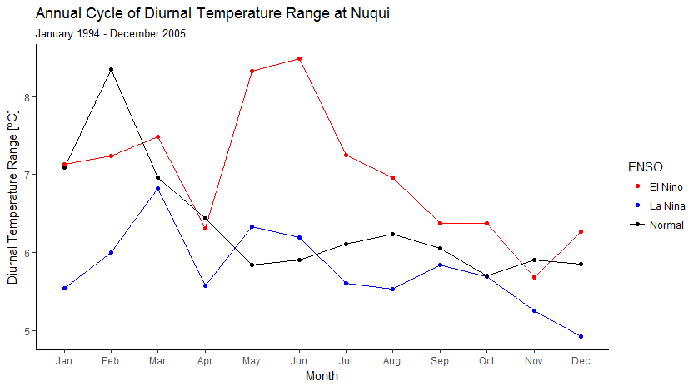

## Boxplots

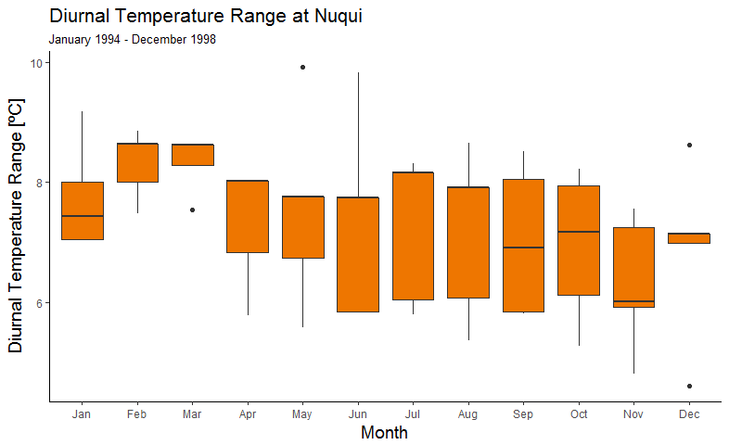

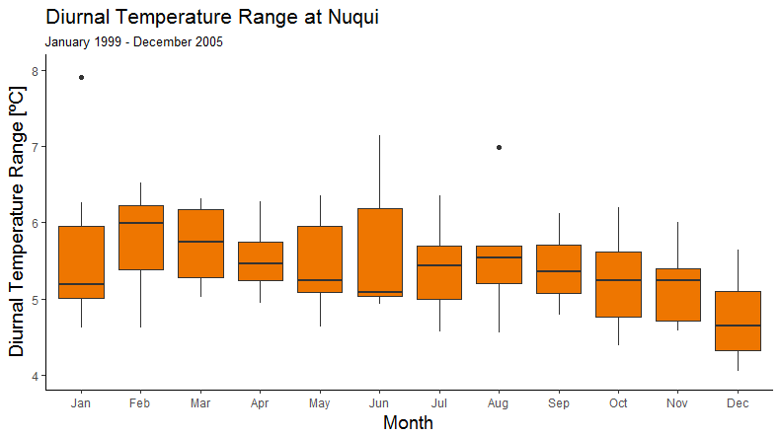

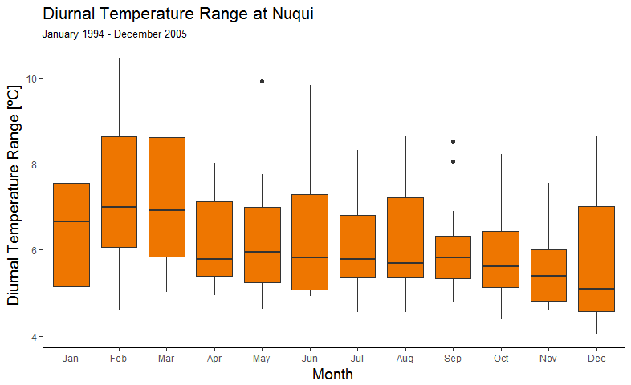

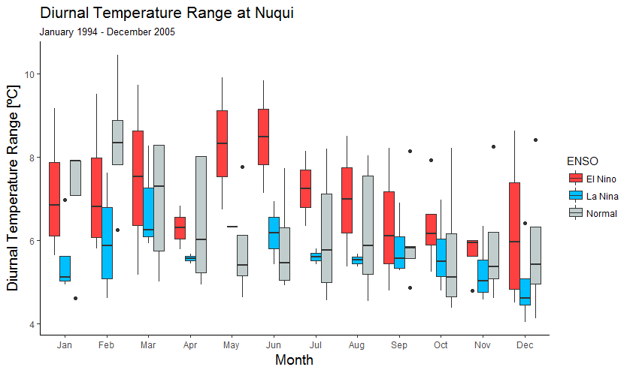

# Lagged Cross-Correlations

Lagged Cross-Correlations were calculated for all the mentioned variables. Cases and the mosquitoes were the fixed variables in Table 2, and Table 3 respectively, while a lag in months were applied to the others. The Oceanic Niño Index (ONI) was calculated based on the monthly Niño-3.4 index (NOAA, 2017).



Table 1. Lagged cross-correlations between the total number of monthly *P. falciparum* cases and other variables.



Table 2. Lagged cross-correlations between the monthly total number of *An. albimanus* female mosquitoes and other variables.

1. Annex:

Bibliografía